**Information on Writing a White Paper[1] and Use of this Document**

**“A white paper is a persuasive essay that uses facts and logic to promote a certain product, service, or viewpoint**.”[2]

In this case you are promoting what you have done in your project. This means you have to report on your developed tool, technology, design or artefact. Remember **not** to write in the first person in any section of your report. The word count, not including references, appendices or diagram/figure/table legend should not exceed 7,000 words (±10%).

**How to use this form:**

This document is only a template. You **must** change the content under the headers and replace it with your own material. You may also create your own document, but make sure you adhere to the structure outlined in this document.

**Checklist before you submit your white paper:**

* Proof read your document and use the spell/grammar check and correct any mistakes
* Check the format, e.g. are any images, tables, diagrams legible etc.
* Check whether your white paper looks professional, e.g., you should probably use a font that looks professional, not something that looks like a handwritten font (or, indeed, an illegible font); there should not be large areas of white space but sufficient space to make the document look tidy; font and spacing are consistent etc.
* Make sure you refer to figures, tables and references in the body of the text. (see Appendix C for examples for the format of figures and tables)
* Include your signed Deliverables & Requirements sheet in an Appendix
* Include minutes of team meetings in an Appendix



**Smart Eco System - Future of Gardening**

Dorota Marczak, Scott Allan, Nader Sobhi

*CMP311: Professional Project Development & Delivery*

2018/2019

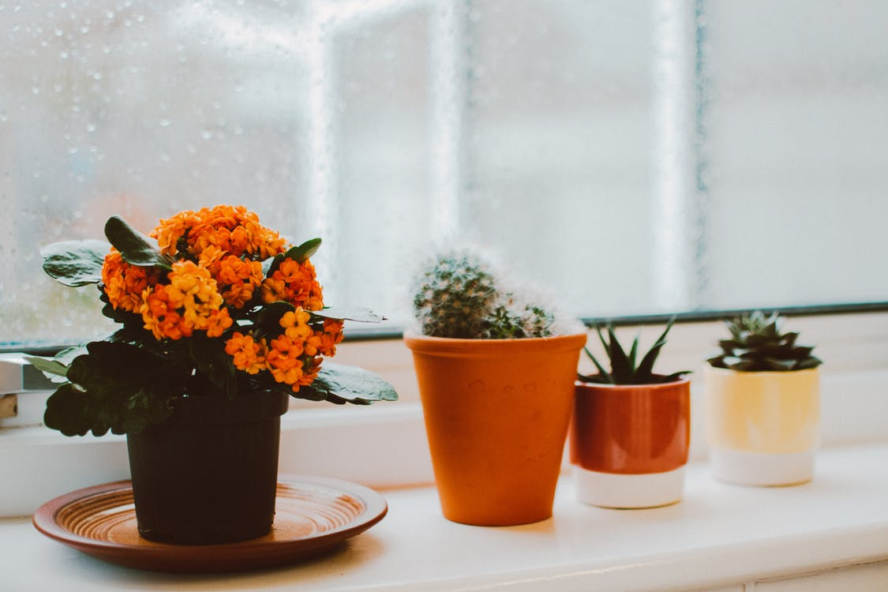

*Please note that Information contained in this document is for educational purposes.*

**Abstract**

**Background to the paper (brief and client) and aim of project**

With the advent of new technologies, which gradually revolutionized countless areas of human life, many employers realized that multiple activities may now be automated, or even performed remotely at relatively low costs. Amidst trending tech solutions such as 3D printing and wireless conference rooms there is one inconspicuous, yet very powerful tool. The Internet of Things, a concept which emerged barely a decade ago, turned out to be a blessing especially for small companies, which constantly compete for shares on the market while having a quite limited budget and human resources. IoT technology can be used for a variety of simple activities, which do not require advanced knowledge or complex operations, performed with users consent and according to their instructions.

Dr Lynsay Shepherd, representing Abertay Plant Systems, decided to take advantage of the opportunities created and ask the local tech start-up - DNS Team – to design and develop a plant monitoring system utilizing above-mentioned technology, as well as similar web based solutions. The client stressed that the company expects a device that could be used by anyone; not only to appeal to their existing customer base but also to “tech obsessed Millennials who care about the environment but don’t keep any plants in their home”. The idea to merge contemporary technology with the age old art of plant keeping was perceived by DNS team as a unique challenge and that is also how it was implemented.

The aim of the project, settled after closer familiarization with provided brief, was to provide an easy to use system that required no expert knowledge to operate and maintain – ideally a ‘plug and play’ device that would begin operation as soon as the end user registered the device on the companion website. Once registered, the device would start to collect data which would then be displayed via the website, as well as via a built in LCD screen. The user could then use this data to ascertain if their plant was growing in the optimal conditions.

**Methodology**

In order to deliver high-quality product within settled time, development of the hardware system and the website was conducted concurrently, which minimized the risk of a potential delay. Team members has been assigned to certain tasks according to their strengths, which facilitated breaking the work down using the Sprint methodology on a later stage. Following Scrum methodology allowed to set clear goals over the course of the development, meaning team leader could track the progress over time. Regular meetings (see *minutes*) were held to ensure the project proceeded as planned, the workload was distributed fairly and finally, that all team members have a chance to air any problems they may have faced with a certain task.

Ready to use product consists of three main elements: Arduino board, connected to a network of sensors and Wemos, database storing the readings, as well as the website, that provides constant control over wellbeing of the plants’ collection. The physical device processes the data received from the attached sensors and sends them in JSON format to the database via Wi-Fi connection, provided by Wemos adapter. The data hold in normalized form are then accessed by the website, that utilizes them to create intuitive data visualizations.

**Outcome**

Professional attitude of each team member to their entrusted tasks resulted in delivering high-quality product a few weeks before settled deadline, what may turn out to be highly beneficial for client’s business and its growth. Smart Eco System, as a user-friendly and visually attractive interface providing reliable information about plant’s conditions and its needs (based on individual settings) has a chance to become a bestseller in the gardening market, which has not fully experienced technological revolution yet. This fact, in turn, may bring common attention of gardeners devoted to their plants and ipso facto originate a mode for smart gardening devices.

Contents

1 Introduction 5

1.1 Background 5

1.2 Aim 5

2 Procedure 6

2.1 Overview of Procedure 6

2.2 Procedure part 1 6

3 Results 7

3.1 Results for part 1 7

4 Discussion 8

4.1 General Discussion 8

4.2 Countermeasures (for a project in ethical hacking) 8

4.3 Conclusions 8

4.4 Future Work 8

4.5 Call to action 8

References 9

Appendices 11

Appendix A - Example 11

Appendix B - Example 11

Appendix C - Suggestions for formatting figures/tables/screenshots in the body of the text 11

Appendix D - Deliverables & requirements 13

Appendix E - Minutes 15

Appendix F – Other 16

# Introduction

## Background

While it is true, that you can happily grow your plants with packet of seeds, a sunny patch of land or simple flower pot filled with soil and a water can, there are much better and faster ways to create your dreamed garden. Less than decade ago modern technology crashed into the gardening sector facing long days of developmental stagnation, interrupted from time to time with new biochemistry solutions. Despite almost unlimited opportunities brought by technological revolution, many gardeners was still confining themselves to obsolete cultivation techniques, originating from first half of twenty century and some even from the ancient times. In many cases, the reason behind it is not related to the potential costs, but rather common habit of following traditions and remaining by the things we already know. However, with the advent of GMOs people began to realize, that it is time to take control over their plant’s fate, remaining almost entirely dependent on weather conditions up till lately. That, in turn, switched on the green light for a whole range of modern solutions, including intelligent automatic watering and remote growth optimization based on cause and effect analysis. It must be noticed, that it was Millennials with their concept of a need being the mother of invention that have leaded the revolution to common success. Instead of relying on a gut feeling and mercurial weather conditions, they prefer to help the nature by in-depth exploration of plant’s environmental preferentions and delivering required mineral resources based on extensive analysis.

According to Washington Post, Millennials began paying attention to the plants they place in their urban flats. Nowadays, they do not only serve as a live decoration or a reference to a favourite aesthetic pattern, but are also a way of expressing unique personality of their owner. As ubiquitous social media encourage young generation to share every piece of their life online, modern middle-aged society is under a pressure of being perfect in every inch and mastering every single field. However, first steps in gardening turns out to be harder than most of them expect. They browse the Internet to find the tips for geeks, but then forget to water the plants regularly and end up trying their luck again. Finally, they reach for gardening applications as a last resort in their gardening adventure. Unfortunately, instead of fully-fledged systems they find crawling applications with basic set of advices and watering reminders being a maximum of their possibilities. Having no choice, they install one of them on the phone and start from the beginning. This time they do not forget about basic needs of their plants and that is usually enough to keep them alive for next few weeks. Proud of themselves, they enlarge their little collection with a few more specimens, which turn out to be even more demanding. Irritated by unprecise advice available on the tags, such as partial shade or medium temperatures, as well as hard to estimate irrigation needs, they look for a tool that would facilitate taking care of their flowers. They are eager to pay for solution to their problem, but unfortunately none of the available products fulfill their needs.

## Aim

The fundamental high-level aim of Smart Eco System project was creating a product, that would meet the needs of modern gardeners; both digitalized Millennials just discovering the world of plants, as well as older members of society experienced in the field, but wary of new technologies.

In practice, the project’s aim is delivering a device, that would collect environmental data on a plant and place them into a database. The readings obtained in this way would then be used by a web interface to notify the user about their plant’s current health by displaying sensor data (or their averages) in the form of clear and visually-attractive graphs. The complete system itself, being the outcome of the project, will give the user the means to monitor their plants as precisely and meticulously as if they were placed in a scientific laboratory. Regarding an experienced gardener, such an opportunity could become the beginning of plant growth optimization, which could potentially save them time and money. The general objectives of Smart Eco System were defined as follows: creating a website housing all the tools needed to take care of a plant’s heath based on collected data. As well as creating and managing a database holding all the necessary information including readings and a list of devices released to the market. Finally, delivering a device that would not only provide an intuitive visualization of raw data received from the physical device, but also to suggest actions needed to take base on them.

Although the main goal of the project was to design and build the Smart Eco System along with a user interface, there were several other objectives identified. Firstly, it is expected that the system will provide a set of features, such as an accessible and responsive website, also including the system’s ability to adapt to different screen sizes that it is being displayed on. The application should be easy to maintain, as basic training provided to the members of staff will not cover the full technical specification and the staff themselves may not have technical expertise. Furthermore, it is crucial that the application was user-friendly and visually attractive, otherwise it may dissuade potential customers from purchasing the product. Another important factor is safety – malicious attacks may cause interruptions in service and these, in turn, may lead to claims of a lesser product if they occur frequently. By treating sensitive data with particular care, the company protects itself against credential leaks, which in turn ensures that they will not have to pay out of pocket to compensate for any damages they may have caused. This would also prevent the tarnishing of the image of a reliable brand.

Regarding the physical device, a vital feature must be reliability combined with a smooth flow of data, as the company cannot afford releasing a poor quality product on an already saturated market. Reducing possible data loss is a minimum requirement. While it is important from the client’s point of view, the user may not appreciate a functional device, that is hard to set up and cumbersome in the same time. Last but not least, collected data must be stored in a manner with the relevant laws of operation of the region, and its integrity should be preserved throughout the system’s life-cycle.

Users should be able to clear data pertaining to them -> FUTURE WORK

# Procedure

## Overview of Procedure

According to Duncan Haughey, author of Project Smart platform, the key to a successful project is a detailed planning. That is also why the next step, taken after setting the goals of the project and identification of the stakeholders, was dividing the development stage into sections corresponding to the settled deliverables. Each of them consisted of a number of features, which has been established based on an extensive list of functional and non-functional requirements, defined by the brief provided by the Product Owner. Before any development work was done on any of the other components, the organization of the database had to be completed in a way, that would enable reception of data from the physical device, as well as to allow the website to read and process the data held within. Then, the team proceeded to the prototyping stage, where each part of the system was analyzed in terms of both its inner range of tasks, as well as the cooperation with other elements of the set. A vital unit considered during the analysis was to find a way to implement a connection to the Wemos board from the Arduino Uno board. Damage to one of the above could result in the potential loss of the ability to transmit the data, which in turn would lead to the failure of the whole system. To avoid this situation, the specialists worked towards the optimization of the wiring and a special case, that would protect the device against inundation and possible breakage. Meanwhile, the sub-team allocated to the development of the user’s online platform performed broad research in order to gain inspiration based on professional, functional and visually attractive services available on the internet. They then utilized the ideas to prepare paper prototypes, which allowed them to achieve as close a match as possible to the client’s requirements. Once this was completed, the developers could estimate the server space required to host the website, so web hosting could be purchased. When both teams prepared a graphical visualization of the part of the system they were allocated to, the team leader called a general meeting in order to discuss the solutions and make corrections wherever necessary. The implementation process ran smoothly and without any major time delays, however it required some inner rotations due to certain unfavorable circumstances. The team members worked collaboratively on the features identified as more complex and time consuming.

## Procedure part 1 – arduino

The hardware device was developed incrementally to ensure that each stage was successful and allow for appropriate testing and modification were required. By building the device in small stages, it allowed the team to track progress as well as served as a troubleshooting guide should an error occur. For example, if the device was behaving normally before a sensor was added, only to misbehave upon integration, it would seem the cause of the error lay with incorrect installation of the new sensor. This section will look at how each stage was carried out and how the overall solution was reached. Connection Diagrams will be provided for each stage, with a complete Diagram incorporating the whole hardware system included at the end of the section.

**Connect arduino and wemos**

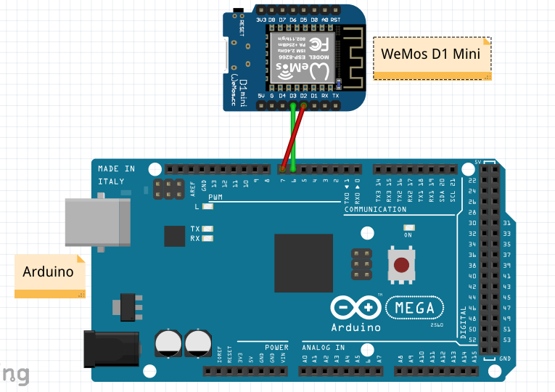

Before we could gather the required data from the sensors to send to the database, we had to give the Arduino the capability to connect to the Internet. This was achieved using a WeMos D1 Mini board. The WeMos is powered by a microUSB connection and uses two pins to send and receive data from and to the Arduino, making it relatively simple to connect and setup. The code running on the WeMos board consists of establishing a connection with the database, listening for the data sent from the sensors via the Arduino, placing the sensor values within a JSON string and finally querying the database and inserting the sensor values in the appropriate table. Once the WeMos has established a connection with the database, it will construct and send a JSON string every thirty minutes. Before any sensors were connected, dummy data was used to ensure that a WiFi connection could be set up between the device and the database server, as well as to ensure that the data was being stored in the database correctly. Once this stage had been complete, the next step was to connect a sensor and obtain useful data.

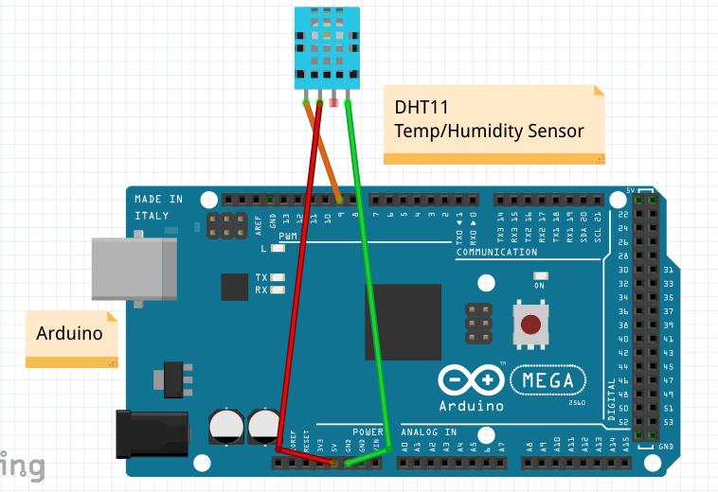

**Connect temp/humidity sensor**

The DHT11 sensor was selected as it enabled the team to take readings on the temperature and humidity in one unit. This sensor requires three pins to operate. It is powered via a 5V pin, requires use of a GND pin and transfers data via a digital pin. A DHT library is also required for successful operation and enables the use of functions specific to the DHT11. The dht.begin() function starts up the sensor, whilst the dht.readHumidity() and dht.readTemperature() functions translate the data received from the sensor into a human readable format. These values are read as floats before being converted to String objects for use with the JSON string.

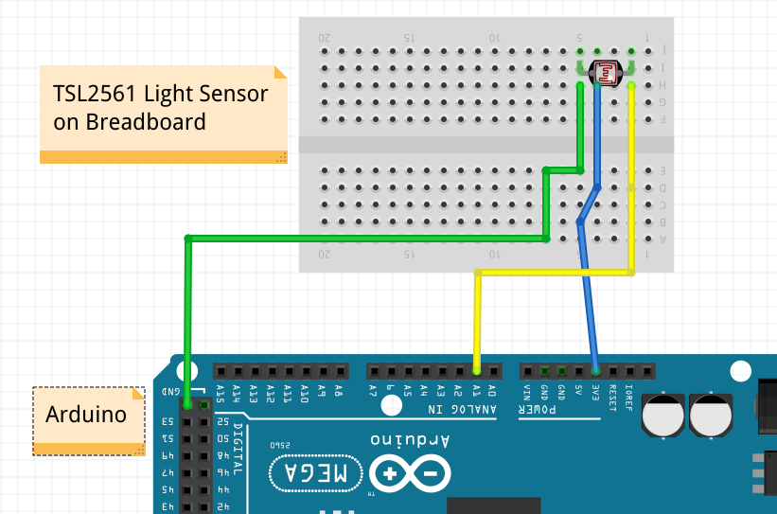

**Connect light sensor**

The TSL2561 was chosen for use as the light sensor as it is very simple and provides easy to use data. The sensor reads the amount of light falling on it in a given environment and outputs this data on a scale from 0-100. This allowed the team to save the data values as an int and display it to the user as a percentage with 0% meaning fully dark and 100% fully bright. The sensor requires three pins to operate: 3.3V to supply power, GND to ground the circuit and an analog pin to provide the data, in this case the A1 pin. A breadboard had to be used as the sensor is very basic and is not attached to a board to provide the pin out functionality. The breadboard can easily be replaced with female-to-male connection wires for a full production model, but the breadboard was kept in place as it allowed the team to daisy chain power connections for other sensors.

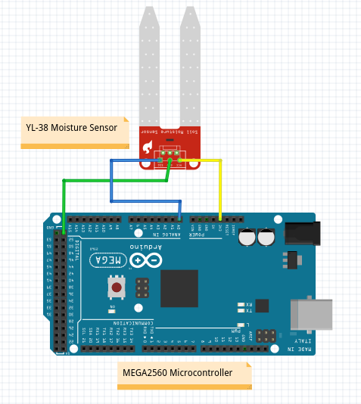

**Connect moisture sensor**

The YL-38 moisture sensor was chosen as it as again easy to connect to the system and provides data that is easy to interpret. The sensor is powered from a 3.3V pin, grounded via a GND pin and sends data through an analog pin, in this instance A0. The sensor works on the basis of a short circuit. The two prongs are connected to the power pin and the input pin and the difference in the returned value is used to calculate how much moisture is present in the given medium. Should the sensor be placed in wet soil, a connection between the two prongs will be established and the value returned will be lower than if the sensor is placed in dry soil where the current finds it harder to travel through the medium. Using this data, we can inform the user whether their plant requires watering or not by using a simple if-else statement to determine where the returned value falls on a scale, as well as collect the specific data value and use it to track how the soil dries out over the course of a day or week.

**Take readings and place in json string**

Once all the sensors were connected and providing useful data to the Arduino/WeMos sub-system, the next step was to place these data readings in a database. There was a number of options the team could have chosen, but the decided method was to insert all the data values into a JSON string and store this string within a database. The advantage of this method was that the database table only required two columns: one which held the unique identifier, in this case the MAC address of the WeMos, and a column which contained the JSON string itself. The team could then parse this JSON string using PHP and use the data to power the graphs on the website. The disadvantage of this method is that the JSON string won’t be sent to the database until it contains four separate readings [one for each sensor], meaning that database entries could be missed if a sensor became inoperational. The advantages here outweighed the disadvantage, which was deemed unlikely to occur unless the device or sensors were deliberately tampered with.

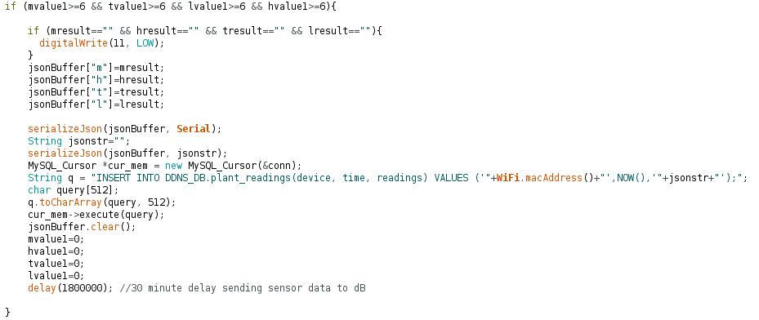

**Send json string to dB**

The WeMos is used to construct the JSON string before transferring it over WiFi to the database. The Arduino collects all the sensor data and passes it onto the WeMos via a digital pin. The WeMos listens for the sensor values and once it has collected all four required readings, a JSON string is created with the values being appended in the appropriate location. The WeMos then constructs a MySQL query consisting of the MAC address of the WeMos which is used as a unique identifier, the current time and the JSON string itself. Once the MySQL query has been executed the JSON buffer is cleared so that it can be used to construct the next JSON string. A delay of thirty minutes is set after which the process begins anew.

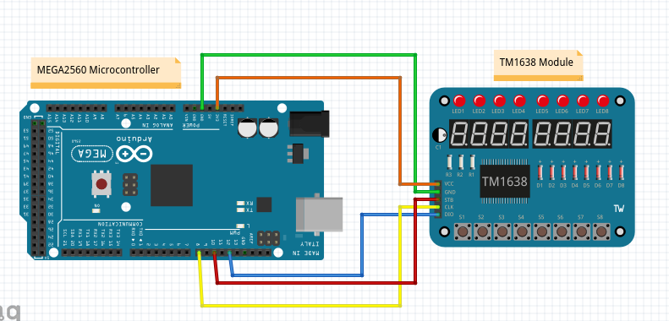

**Connect LED display**

Whilst the data collected from the sensors has more use in powering graphs in place on the website, a simple display was implemented so that the user can see the real time data collected from the sensors. A TM1638 module was selected as it contains eight seven-segment displays that can be used to display basic letters and numbers and eight buttons which can be used to make selections. A TM1638 library was required to access the functionality of the buttons, via the module.getButtons() function, and allow data output to the seven-segment displays, via the module.setDisplayToString() function. The team decided to use the first four buttons to switch between which sensor reading was currently displayed, with the default display and button showing the temperature reading. The second button was set to display the humidity reading, third to display the light level and the fourth to display whether the plant required watering or not. First all of the sensor values had to be converted to String objects as this is what the seven-segment displays required. A series of if statements were then used to interpret which button was pressed and the appropriate reading would be displayed to the user [see below code snippet]. The module used also benefits from requiring only 3.3V to run, lessening the overall power draw of the system. More complex displays could have been used, but the data displayed would remain much the same but the power draw of the device would be increased.

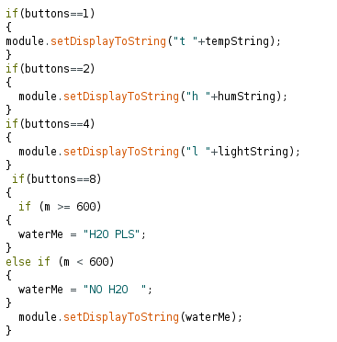

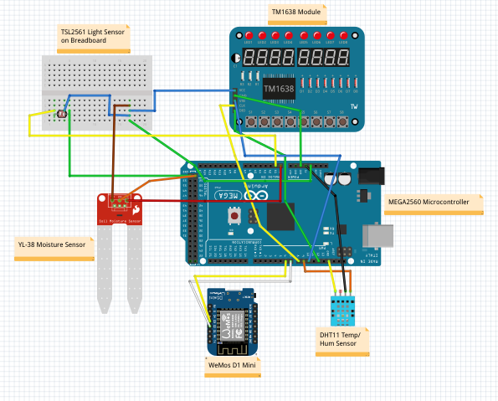

**Complete system circuit diagram**

## Procedure part 2 – WEBSITE

Designing an online platform, which would provide the means to monitor the plant’s growth, began with establishing a list of functional and non-functional requirements, that it was expected to fulfill.

First and foremost, the website aimed at the presentation of the collected readings in a graphical manner, which could serve as a base in performing precise development analysis. That, in turn, may significantly facilitate optimization of plant’s growth due to how important role the environmental conditions play in the gardening world. Also, the platform is required to provide a way to register the device and the plant it is placed in. By purchasing the product, the user obtains the access to the activation code assigned to the physical device. Logging into the system and adding the device is all it takes to begin a gardening adventure. Apart from aforementioned features, the requirements regarding the Smart Eco System’s website included accessibility (as a basic human right by virtue of UN Convention on the Rights of Persons with Disabilities), as well responsiveness, protection of the stored data against malicious attacks and visually attractive, user-friendly interface.

Regarding the complexity of Smart Eco System, as well as the differences between the presentation and functional part of the website it was decided, that the most favorable solution would be splitting the platform into pre- and post-login version. By separation of those logically independent parts, the company got the chance to make the most of the marketing opportunities created. Therefore, the front page, being to some extent a business card of The Abertay Plant Systems, was expected to provide basic information about the company and its innovatory product released recently as a part of its pioneer project. In order to organize the development process, all the requirements were converted into an extensive list of features, which were then allocated to sprints. Next, the first prototypes of both parts of the website were designed. Out of six front page versions designed by the sub team responsible for web development, the project manager decided to choose and implement three, which were considered as outstanding in terms of visual attractiveness and functional solutions. Although each of them made a good impression on a paper, two of the implemented prototypes turned out to be potentially hard in maintenance and characterized by a low responsiveness level (Fig.x, Fig.a).

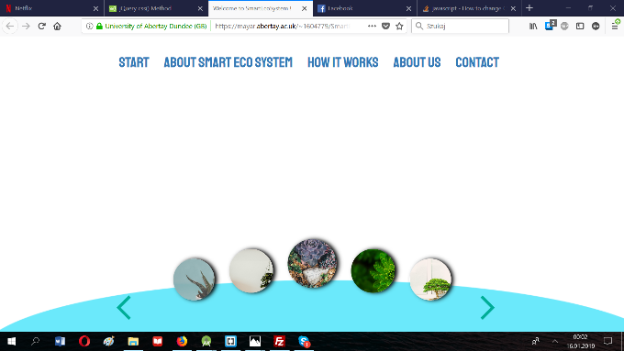

**Fig. x Prototype rejected due to scalability problems of one of the feature**

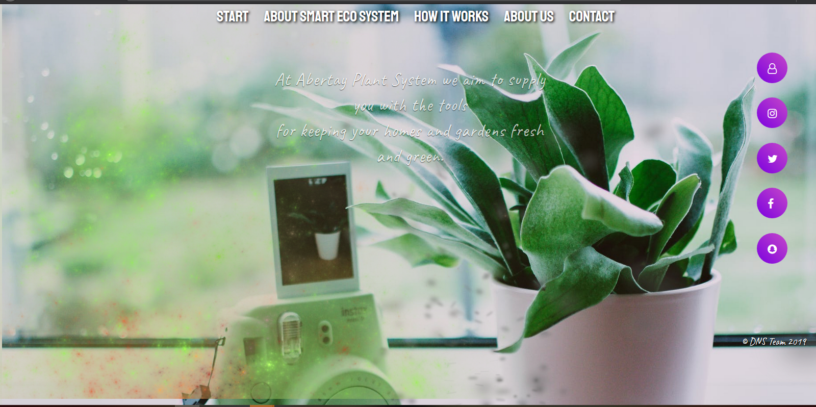

**Fig. a Prototype rejected due to low level of responsiveness on mobile devices**

Therefore, the final choice felt on the prototype, which combined the simplicity of expression with visually attractive, minimalistic layout adapted to different screen sizes. Having added a stylish font and high-quality picture in the background, the prototype gained desired outlook and could be extended with further elements (contrary to most of the prototypes, this one was not supported with any fully-fledged programming language and hence did not pose a threat of missing out on vulnerabilities to malicious attacks).

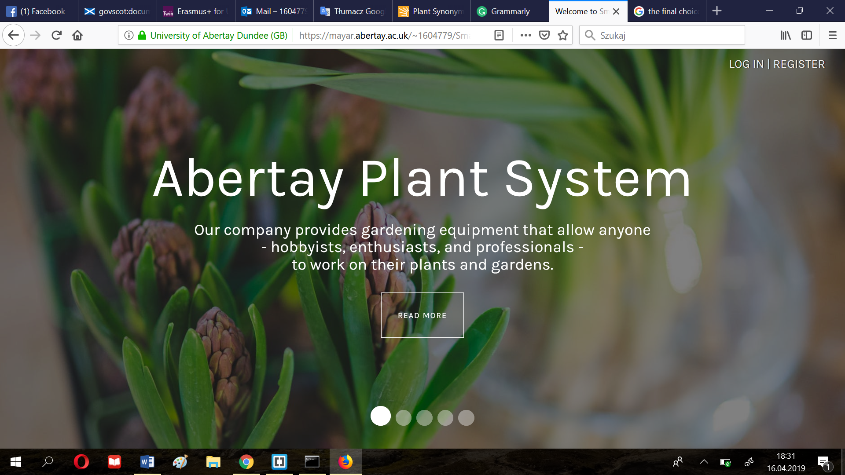

**Fig. y Leading prototype of the front website**

The development process began with enriching the application with the sliding mechanism – Bootstrap Carousel, which added the dynamism to the minimalistic design (Fig.a).

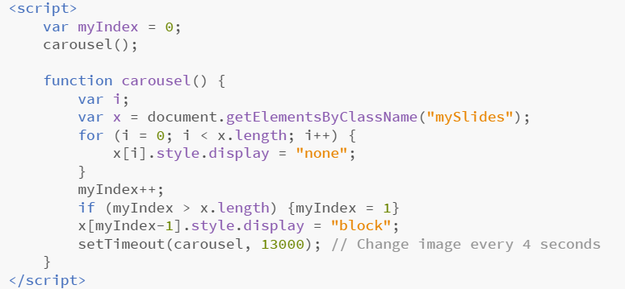

**Fig.c Carousel mechanism (javascript)**

The content of the front website has been separated into five slides, which aimed at creating an effect of a digital brochure, directing the user to the most important – contact with the producer (Fig.c).

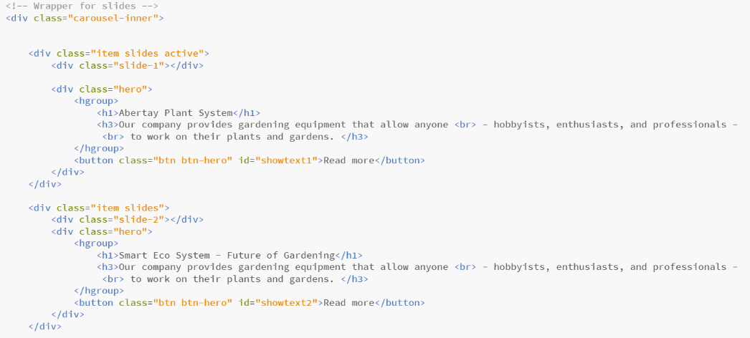

**Fig.c Construction of the front website**

In order to allow the user to freely navigate between the slides, the team supplemented the website with corresponding buttons, adapted both to desktop and mobile version (Fig.s). Next, the team decided to display the content allocated to each slide in an overlay in a way, that would avoid fully covering of the main page, giving an impression of fluidity and lightness of the design.

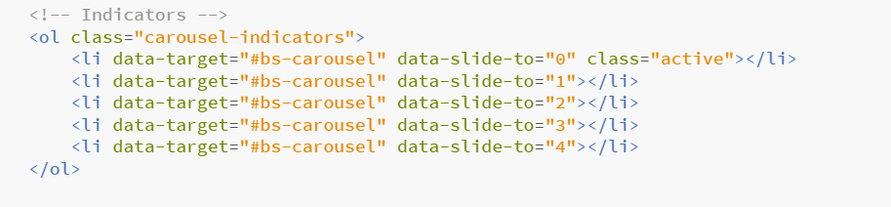

**Fig.s Slide indicators**

Having implemented the additional layer(shape of which has been designed in GIMP image editor), as well as filling in the empty space with the proper content, a return option and a decorative element, the platform has finally gained a professional character and following this, fulfilled its informative role (Fig.d).

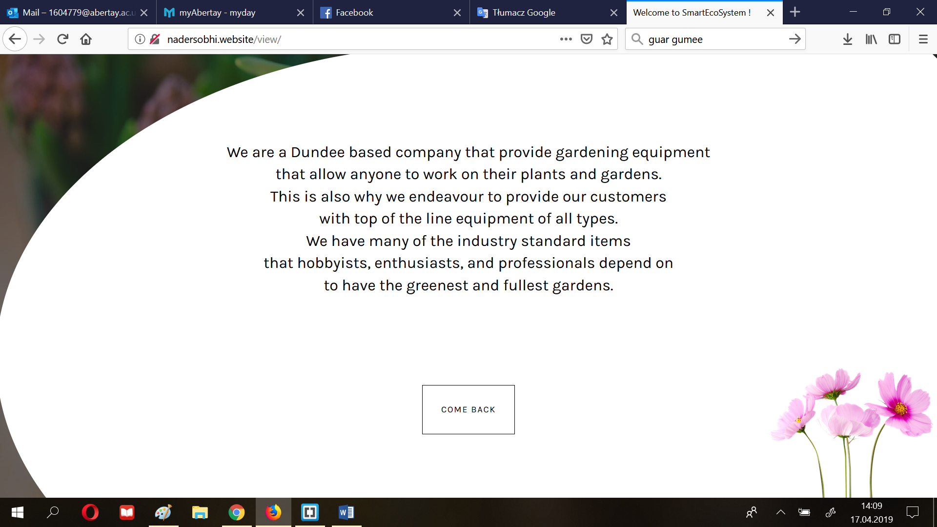

**Fig.s Example content of the ‘pop-up window’**

Prior to the implementation of the login & register facility, the team established a user table in a database, which would correspond to data required in the form. It consisted of a username and hashed password, the elements required for user authorization, as well as additional data such as email and full name.

Also, the table has been normalized in third normal form, which excluded potential data repetitions.

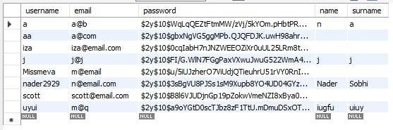

**Fig.d User table (filled with test data)**

Regarding the registration form, it was implemented by combining front end and back-end elements responsible for placing the data in the database. Once submitted, the data is sent with the POST method and is processed by the API with additional precautions, including parametrization of sql queries (Fig.e).

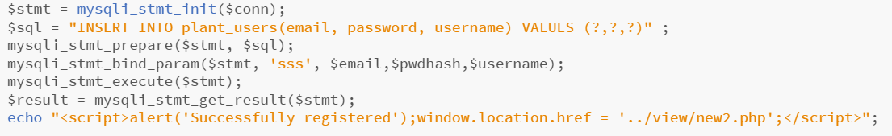

**Fig.e Inserting the user into the database (API)**

Though the main functionality of the front website has been finally implemented, one of the quality controls performed throughout the development process indicated a need for enriching the website with a function, that would allow the mobile users to move between the slides using touch instead of provided buttons. After a broad research it was decided, that swipe function available at jQuery library will be the simplest solution amidst all available frameworks and libraries available in the Internet (Fig.f).

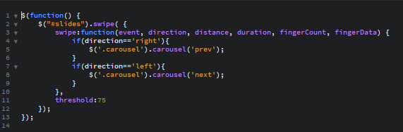

**Fig.f JQuery function for swiping slides on touch (mobile devices)**

The implementation of the second part of the website began with establishing a responsive, collapsible menu, which would allow the user to move to the desired content of the website with a single click on one of the available subsections. Moreover, the menu was designed to highlight the subsection currently in focus, as the usability of the platform was one of the main requirements (Fig.r).

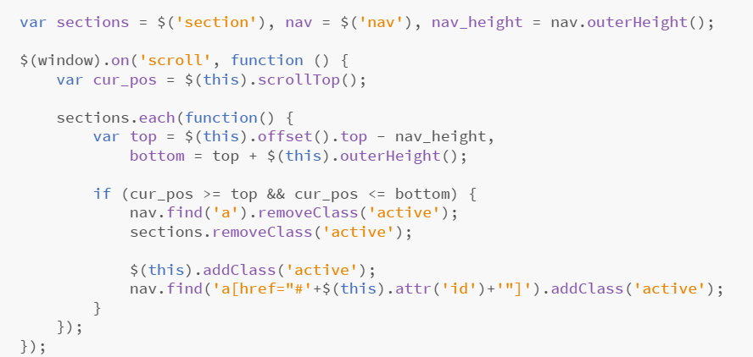

**Fig.r JQuery function for detecting the active element (subsection)**

Another step taken by the team was implementation of the form, that would allow the user to assign the purchased device to the chosen plant. Apart from device ID and species of the plant, the user is requested to choose the picture, as well as the plant’s environmental preferentions, which will then serve as a basis for status of the plant. In order to prevent the user from adding the plant with incorrect device key, the system can place the plant in the database only if it is supported with readings available in corresponding table. Also, the system was additionally improved by adding the measures to check, whether the device will not be duplicated by any of the users (Fig.f). -> ADD SCREENSHOT

Subsequently, the team has briefly analyzed the table storing the plant’s readings (id of the reading, device key, time and data in the JSON format, Fig.h) and based on that created a simple user panel (Fig.g). Its main purpose was to provide the latest data on current environmental conditions the plant grows in. However, in order to increase the functional value of the platform, the panel was enriched with the plant’s image, as well as the watering suggestions and the buttons, designed to extend the page with further readings‘ analysis provided in the form of graphs.

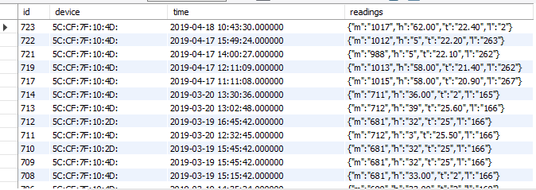

**Fig.h Plant readings**

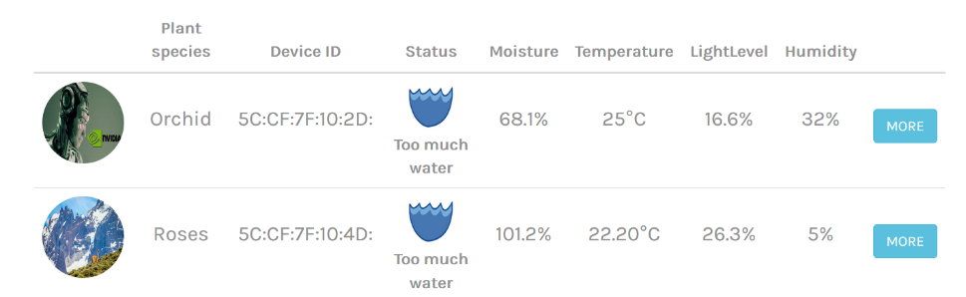

**Fig.g Plant monitoring panel**

Once the basic functionality of system has been finally achieved, the team proceeded to the implementation of the graphs based on the database environmental data. Having performed a broad research, the developers decided to utilize Chart.js – open-source javascript library providing animated, interactive graphs. Each graph offered three types of views: day, displaying the readings in half an hour distance, week, consisting of six graph bars corresponding to averages of every four hours of readings, and month, based on the average of each day. -> ADD CODE THERE

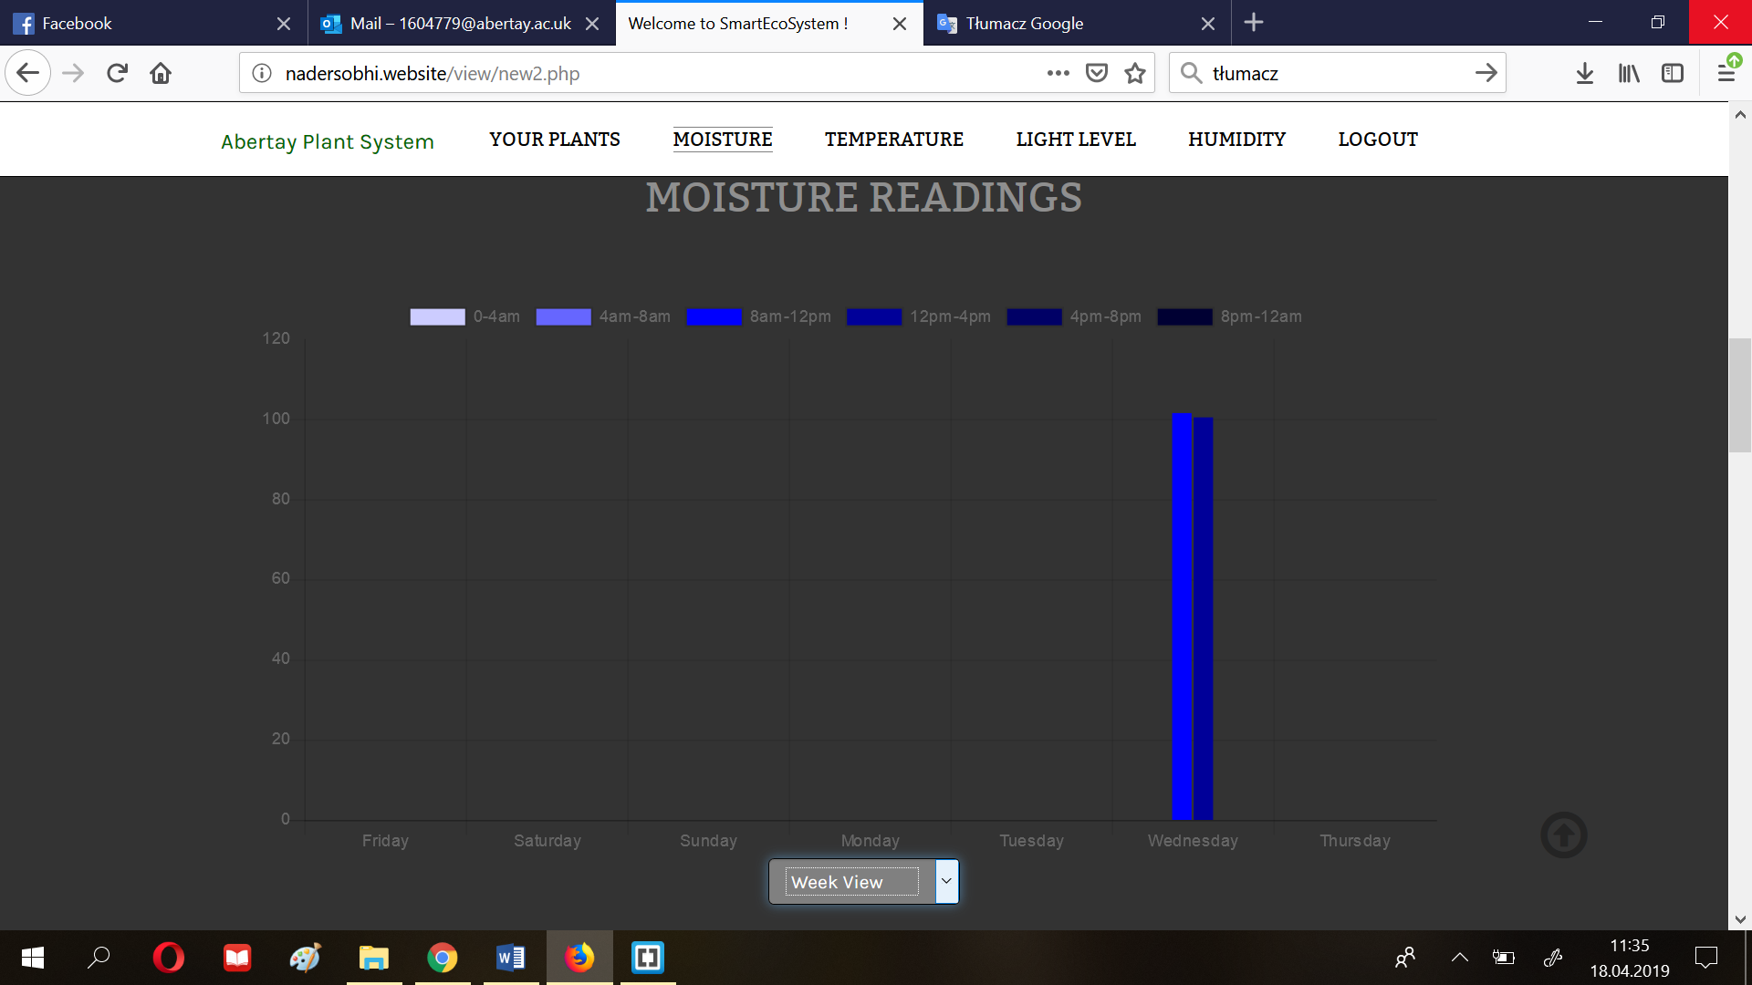

**Fig.y Example of weekly readings**

Last but not least, the website has been enriched with certain less noticeable yet important features in term of usability. To begin with, the front website has been supplemented with cookies, so that the user avoided typing the credentials every time they open the website. Then, the developers activated the user sessions (safety measure against shared computers) and added the scroll button, which was considered as a useful tool for navigating through the website.

# Results

Put your results in here. Any tables or results should be included here unless there is a large amount of data. Appendices should be used for large amounts of data and referenced in the text. Only important details should be included in this section, i.e. material that convinces your client about the (hopefully fantastic) performance of your design/tool/etc. Consider what is important here to make your project look good.

## Results for part 1

In this section, the results of the above outlined procedures will be discussed. The results will be discussed in three individual sections, with a brief conclusion of the overall result of the project closing the section.

Arduino Results

The manner in which the hardware system was put together allowed for results to be gained incrementally, that is to say that once one peripheral had been attached, it was tested to ensure it was sending the correct data and then the next peripheral was attached and so on.

Arduino and WeMos

The WeMos unit was the first peripheral to be attached to the Arduino unit. It was decided that ensuring a stable WiFi connection could be achieved was imperative to the success of the project/ This stage was undertaken first to ensure that a connection could be achieved as well as having a good starting point for sending sensor readings to the database once they were connected.

To test that the system worked, the Arduino was given a string that it passed to the WeMos. If the WeMos received the string, it would display it in the Serial Monitor of the Arduino IDE. Once successful, this destination of the string was then changed to the database to test the WiFi connection and whether the data was held correctly in the database.

This result was important as it gave the team a solid platform to build upon. The WeMos also has a unique MAC address which is used by the database as the primary key for grouping and sorting data. This not only means that the MAC address cannot be accidentally overwritten or altered (it is stored in the WeMos firmware), but if the system ever experiences a loss of WiFi connection, a new WeMos unit can be swapped in without arduous refactoring of code.

Arduino and Sensors

The sensors selected for the project were chosen not only for their ease of use regarding system implementation, but also on how they returned data to the system. For example, the DHT11 sensor was used to collect temperature and humidity readings. Not only did this combine two sensors in one, it also returns readings in terms of degrees Celsius which meant that accurate results were being obtained as soon as the sensor was connected properly. This scenario was similar for the other sensors chosen in the project.

Testing of the sensors followed the same process as testing the WeMos connection. The sensors would return values and these would be displayed in the Serial Monitor. This allowed the team to fine tune how they wanted the data to be displayed as well as test that it was held correctly in the database.

Arduino and JSON String

The team decided that instead of storing the sensor readings in separate columns within the database, a JSON string would be used to collate the data and be held in one column of the database. The thinking behind this was based around how efficient the system could be at sending data as well as making it easier to parse this data for use on the website. Rather than sending four separate pieces of data to the database all at slightly different times, a JSON string is created that takes all four data ‘chunks’ and appends them sequentially. Once all data chunks have been received, the JSON string is then sent to and held in the database. This means the website only has to access two columns in the table (the ID of the hardware system and the JSON string) and can then parse out the required data from the JSON string where needed. This means that all four sensor readings will be sent at the same time, removing any discrepancies in the times of the collected data.

Arduino and LED Display

Whilst it was accepted that the main use of the data collected was to power the creation of graphs and charts on the website, the team decided that being able to view real-time data via a hardware display might also be useful for fine tuning the placement of a subject plant or communicating whether the plant needed watering or not. In order to achieve this, the TM1638 module was selected because it features a display and switch buttons on the same unit. The switch buttons would allow different data to be read on the same display without the need for having unique displays dedicated to showing one value from a particular sensor.

The display itself is made up of eight 7-segment LEDs, a rather simple form of display but one that was perfect for displaying numbers, which would mainly be the datatype on show. However, the display can have problems displaying certain letters of the alphabet, ‘M’ and ‘W’ being prime examples. Despite this potential limitation, the team viewed this as a unique creative challenge. Four readings had to be displayed on the screen, namely temperature, humidity, light level and moisture level. To ensure that the user knows which sensor data is being displayed, the first LED displays a lowercase letter relating to the sensor type; ‘t’ for temperature, ‘h’ for humidity and ‘l’ for light. Displaying the moisture level was more problematic, in that while the light level figure could be displayed, it could not be labelled the same as the previous three sensor displays. To overcome this, the code was modified slightly so that the display reads ‘H20 PLS’ if the plant requires watering or ‘NO H20’ if watering isn’t required. Whilst the display isn’t uniform in how it communicates the real time data to the user, the display device has been kept as the TM1638 module as it is simple to use, displays data accurately and draws very low power compared to more complex display modules. With the switch buttons being part of the module, this reduces the footprint of the hardware system as well as making the back end code a lot simpler.

# Discussion

## General Discussion - Scotty

This section will look at the project as a whole, how it relates to similar solutions already on the market and how it meets the aims set out in a previous section.

The project as a whole has been very successful in terms of producing a hardware and software system that accurately collects, records and displays data about a specific plant. Whilst on paper this may seem like a trivial exercise, translating this into a system that is robust enough to deal with changing variables while collecting useful information is quite another challenge. It would not be enough to build the hardware system and have nowhere to send the data for display just as it would not be sufficient to develop a website and hope that the sensor data would be displayed in a human readable format. Care had to be taken to ensure that the data collected from the sensors was in a human readable and useful format before it was sent to the database. The database itself had to be designed in such a way that the website could access it easily and simply extract the data it required. The website then had to use this data to power graphs and charts that the user could use to track the status of their plant over a given time frame.

It is important to evaluate the project in regards to similar devices currently on the market. The Plant Monitoring System created by Ryan Gill uses similar components to achieve a similar result, but it relies on slightly inflexible open source software to collect and render the data. The system developed by the team has enough scope that sensors can be added with only slight alterations to the code base, should the client wish to produce a range of products, such as an entry level model to an expert model with stages in between. Gill’s system also requires technical expertise to put it together, a factor the developed system negates. The total cost of Gill’s system is slightly less than the teams system, but any potential saving is destroyed by the technical knowledge required to build it.

The Smart Plant Watering system by Electrow again uses similar components, but adds in the feature of remote plant watering. However, this not only greatly inflates the cost to be over£100 more expensive, but the technical knowledge required to build it is vast. This system also avoids any data collection and uses only moisture sensors to coordinate its operations. However, the inclusion of remote plant watering makes it a very interesting device and should be considered in future iterations of the developed device.

The Smart Garden System by SwitchDoc is perhaps the industry leader in regards of smart plant monitoring. It uses a Raspberry Pi in place of an Arduino, which gives it much more processing power and the ability to add sensors and modify the code. However, it requires some technical knowledge to put together, takes up a much larger footprint and is also much more expensive that the developed device. The ability to monitor more than one plant from the same ‘brain’ is a highlight, as is its integration with digital assistants like Amazons Alexa.

All of the devices mentioned do very similar things as the developed device as well as features beyond the scope of this project. However, they all suffer from the same flaw: they require specialized knowledge to build, operate and maintain. This is where the developed device stands on its own.

In a previous section, the aims of the project were laid out. It is important to evaluate how well the project meets those aims discussed.

The high-level aim that was set out stated that a product should be created that met the needs of the modern gardener, both those just discovering the field of horticulture as well as more seasoned individuals. The goal here was to develop a system that was not only easy to setup and use, but also one that would feedback useful information to the user that they could then use to make informed decisions. Overall, the project achieves this aim well. The physical device has been developed to include as little peripheral modules as possible whilst still maintaining a high degree of usability. To set up the device, the user has only to place the sensors where they feel is most accurate and then power the device on. Inserting data into the database is done automatically upon a WiFi connection being established. The user then has to register with the companion website to view the graphs and charts powered by the collected data. The website has been designed for use with mobile and desktop devices in mind, a design consideration with both ‘digitalized millennials’ and more mature members of society. A young professional can check on the status of their plant whilst on the evening commute, while a retired individual can use the historic information collected to chart their plants progress from their desktop PC, allowing both to develop new strategies and refine those currently in place.

In addition to this over-arching aim, several smaller aims were identified. Firstly, the website had to be responsive in order to display correctly on a mobile device as well as desktops, laptops and tablets. Consideration on which browsers being used played a part here, as older users may be prone to continued use of legacy browsers, such as Internet Explorer. Navigation and content of the website was also a crucial consideration, with the aim of ensuring as few button clicks as possible resulted in the user locating the desired information. Secondly, the device had to be easy to maintain with little or no expert knowledge required, as well as perform in a reliable manner. The developed hardware device is essentially ‘plug and play’, with the user having merely to place the sensors and power the device on. The components used are rugged enough to withstand repeated use but also simple in their operation. The reliability of the device is dependent on the WiFi connection. If a user’s WiFi service was to be interrupted, sensor readings may not be placed in the database. This, however, is out with the scope of the team but in attempt to less such an impact, sensor data is only sent to the database every thirty minutes. Lastly, collection of data had to be undertaken in a manner appropriate with current legislation, with consideration being given to how these laws may change in the future. While the hardware device is geared toward collecting data, the only piece of personal data the user has to provide is their email address. This is so that they can register a username and password for use on the site with the email address only being used should they request to set their password. However, the website does contain a ‘Remember Me’ function that uses cookies to store session information. To inform the user of this, a pop-up is generated when they visit the site to inform them that cookies are used. After agreeing with this, they are free to use the website. This follows GDPR legislation dealing with the collection of cookies.

It is fair to say that the overall project meets the needs of the client as well as the aims set out. The client wanted an intuitive, adaptable system that could collect, record and store data on a given plant. This was achieved. The aims then expanded on the client’s needs to ensure the device was reliable, responsive and easy to use. This was also achieved.

## Conclusions

Smart Eco System is a unique product, designed to help the client attract not only gardeners actively looking for the newest solutions of plant growth optimization, but also Millennials, who currently constitute a minority in the gardening market. Having access to the readings presented in the form of visually attractive graphs, as well as the indicators showing plant’s demand for water, all they need to do is to regularly check it’s status by logging into the online platform.

Moreover, such a technology could potentially raise the prestige of the company and significantly contribute towards the business’s development, and thus increase the number of connections in the industry. It would change the perception of the company from a small, local shop to competition others have to reckon with. That, in turn, would translate into bigger profits due to their new-found reputation as a pioneer of smart home equipment.

However, if the client, for some reason, decided not to release the product, the aforementioned competitors would definitely take advantage of the company’s stagnation and introduce interesting technological solutions. By doing so, customers would be enticed to purchase their gardening tools from their stores and not from Abertay Plant Systems.

## Future Work

As with any project created to fit a client’s specification there are some features or aspects of the system that were identified as potentially beneficial but were not implemented due to some extenuating circumstances. Starting with the database a NoSQL solution could have been implemented instead of the current model which currently consists of a mix of Relational Database Scheme (RDS) and a NoSQL scheme. The reasoning for this was that the information stored currently would only consist of some basic user information, the sensor readings from the device(s) and nothing else. However, in the future it may be prudent to switch the storage method used for this data to a NoSQL solution as it would allow for the easy expansion of any of the data centric features. An example of this would be allowing multiple people to use the same account and therefore expanding the users table. This is really the only change, identified by the developer, that could be implemented with regards to the database.

As opposed to the database the physical device responsible for collecting readings on a plant’s surroundings could be improved in a multitude of ways. These are mainly quality of life changes and therefore were not implemented at this point in time. Beginning with the implementation of some sort of interface for the Arduino Collective so as to allow the user to perform a few actions that are currently unavailable or only available through the web application. As far as the developer can identify there are only 3 ways that an interface could be implemented to allow the user to control the device’s functionality. The first would be a custom-built application that would interface with the device once it is connected to the user’s personal computer. This version would allow the user to make changes to the device’s functions through the interface and then the appropriate instructions would be loaded onto the device. This iteration would be the simplest to implement as the Windows OS can already recognize when an Arduino device is connected. The second way to implement an interface would be to use a display and a number pad that operates in a similar fashion to the keys found on older mobile phone devices. This would allow the user to directly control the device without the need for an intermediate medium. Although a functional and novel idea for an IoT device, the implementation of this idea was deemed as too difficult to complete within the allotted time. Finally, another method that could be used to implement an interface would be to use the website to allow the user to set some options that would control the functionality of the device and then load those the appropriate device instructions onto the device. This is probably the hardest, of the three models described for device interfaces, to implement as it requires that two-way communication is possible between the device and the website. Additionally, it would require more storage for user preferences as well as more data to be collected on each individual user. Continuing with the device, another aspect that could be implemented in the future would be to allow the user to sustain or nourish the system through the device itself, mainly watering and providing light to the plant. This feature ties in with the previously mentioned future improvement of implementing a device interface as it would allow the user to not only monitor the devices status but to react by activating a watering or lighting mechanism to provide sustenance to the plant. The reason this was not implemented was that the developers felt that this would be fairly trivial to implement at a later time when some type of interface had been designed and attached to the device. Lastly and least importantly at this stage would be the design and construction of a plastic 3D printed case for the device to be housed. This was done due to the extremely limited access the developer had to such a printer.

The website is the final component which holds potential for future upgrades or modifications. Beginning with the addition of a feature that would allow the user to regain access to their account should they forget their password. There are plenty of methods that can be used to implement such a feature, including email reset links or other two factor authentication methods. This was, again, not implemented due to time constraints and not due to difficulties in implementation. Another security feature that will be implemented in the future will be the use of the HTTPS protocol to encrypt connections between the users and the website. This was not implemented because the web hosting used did not support the developers preferred method of adding the required certificate to the website and thus would require more work and time than available at that point in time.

Apart from security features there are some functional aspects that have not been implemented due to time constraints as well as the fact that they were deemed as small quality of life changes and therefore would not improve the functionality of the system by a significant amount. That being said, they will be discussed here as potential improvements for the system in the future. Starting with the implementation of a feature that would enable users to discuss plant care with plant experts or members of the user base who have proven to be extremely adept at plant care. This would allow for a kind of social network that would enable users to interact with other people who share the same passions as them. Another quality of life change that would improve the overall usability would be to add a feature that would allow users to upload a picture of their plant so that a trained AI model that would identify the species of the plant and suggest methods to improve the plants health. This feature could also be extended to utilize the portion of the website that asks the user to enter what they think are the ideal environmental conditions for their plant. While this is a novel and potentially useful idea, to build such an artificially intelligent model would require a large amount of development time as well as a huge dataset of pictures of all the most likely types of plants to be used with the system. Meaning that it was not be possible to implement at this time. Finally, another feature that could be implemented in the future would be to add a “wiki” type section of the website that would host all kinds of information about plant care. While very easy to implement this can be very time consuming as it would require the developer in charge of the task to do extensive research so as to ensure that the information hosted on the website is accurate. This is also the reason this feature has not been implemented as of yet.

## Call to action - scotty

To find out more about how you can gain the power to track and optimize your plants lifecycle with the Abertay Plant Monitoring System, visit [www.abertaypms.com](http://www.abertayps.com) today to arrange a free, in-depth demonstration. The first fifty people to sign up for a demonstration session will receive 25% off the total cost of purchasing the system and six months of ongoing training and technical support. The first hundred people to sign up will receive six months of ongoing training and technical support. The only way to take advantage of these offers is to visit [www.abertaypms.com](http://www.abertaypms.com) today and register your interest in the Abertay Plant Monitoring System!

USER MANUAL

1. Visit the online address - [*http://nadersobhi.website/view/index.php*](http://nadersobhi.website/view/index.php)

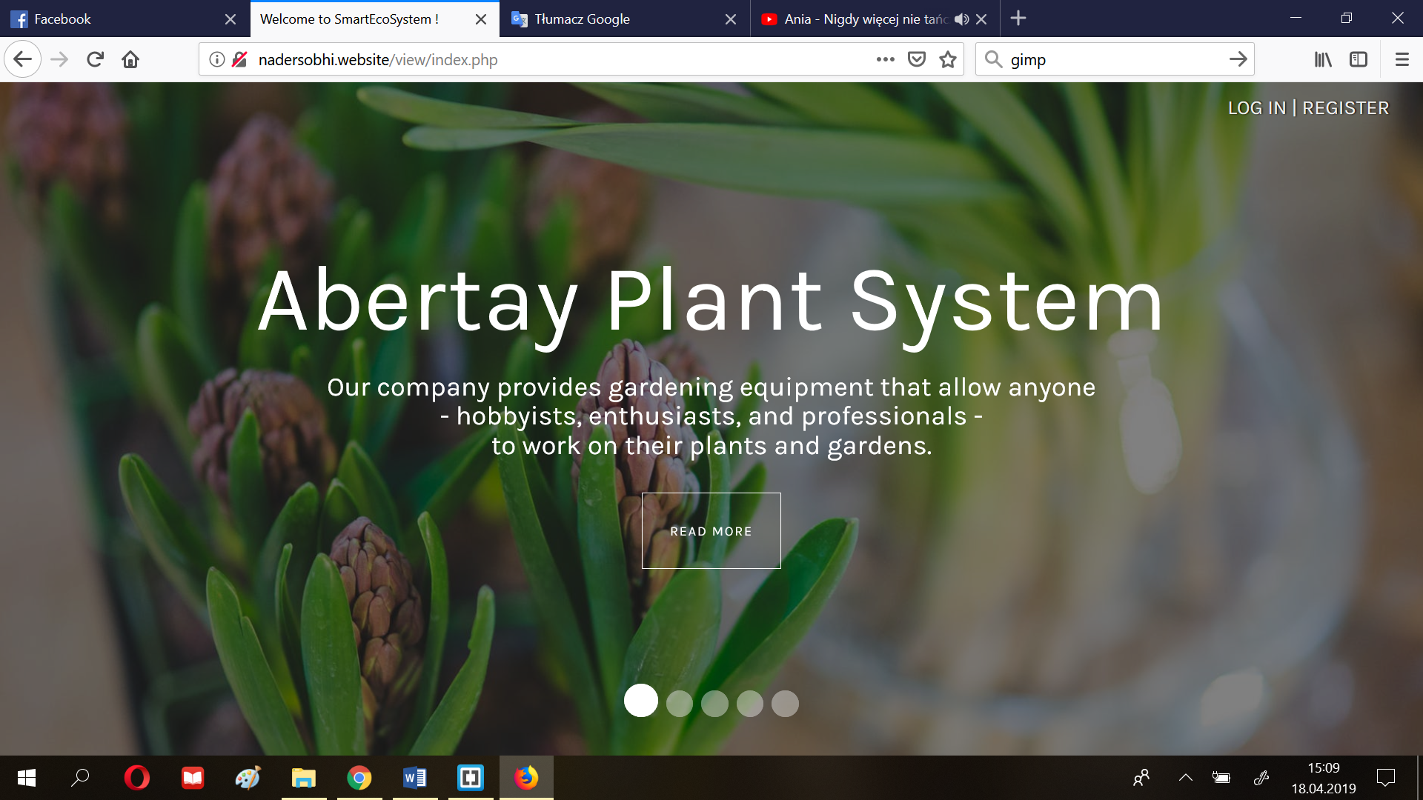

1. Register an account by clicking on the button ”Log in|register” and filling in the form

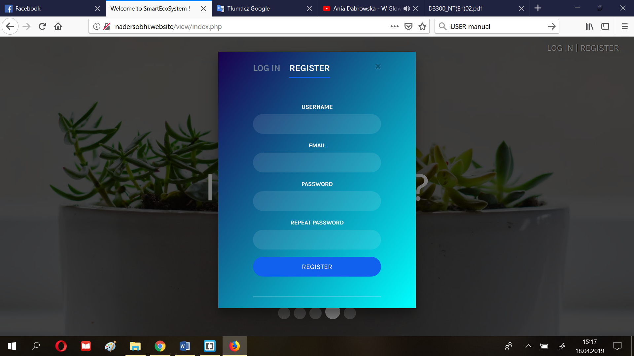

1. Click “+” to add new plant to your list (follow the blue arrow)

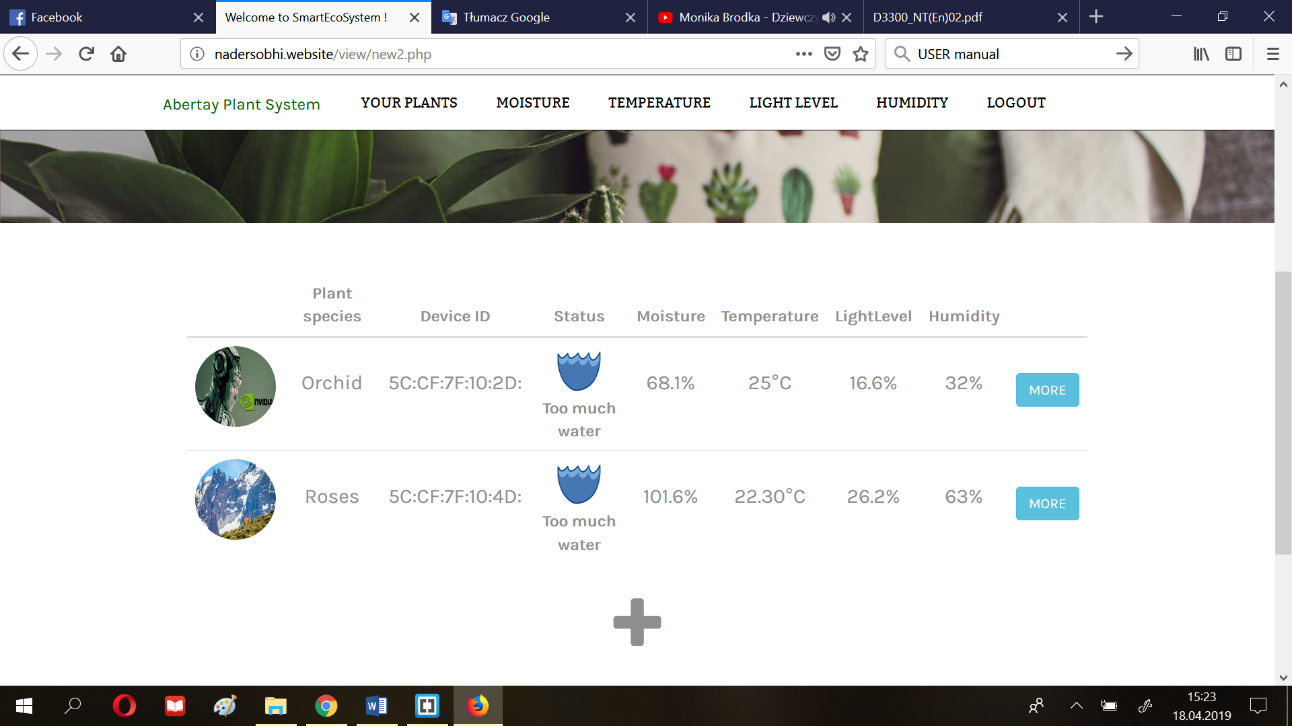

1. Fill in the form adding the image of your plant, key (ID of the device), plant species and environmental preferances, and press the ‘submit’ button to confirm the operation.

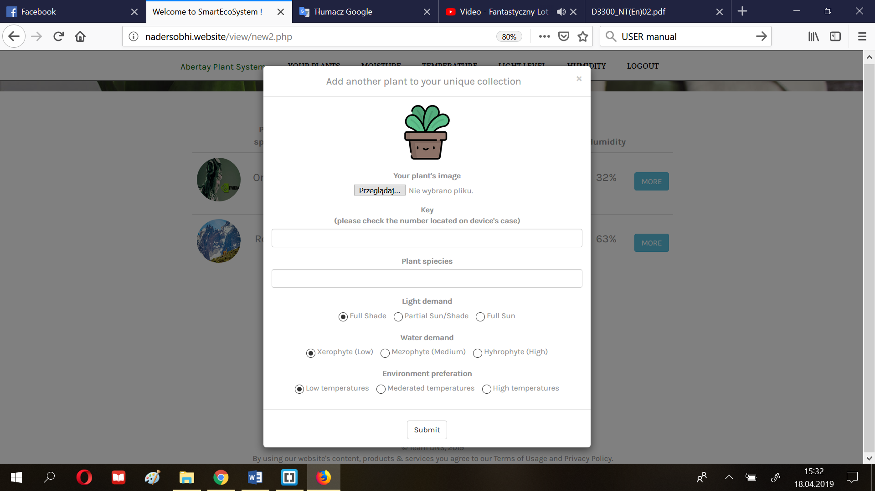

1. Choose the plant by clicking ‘more’ (step 3) and browse the graphs at your leisure.

Move between them even faster with ‘scroll-up’ button (blue arrow) or use the menu, which will automatically carry you to the desired section.

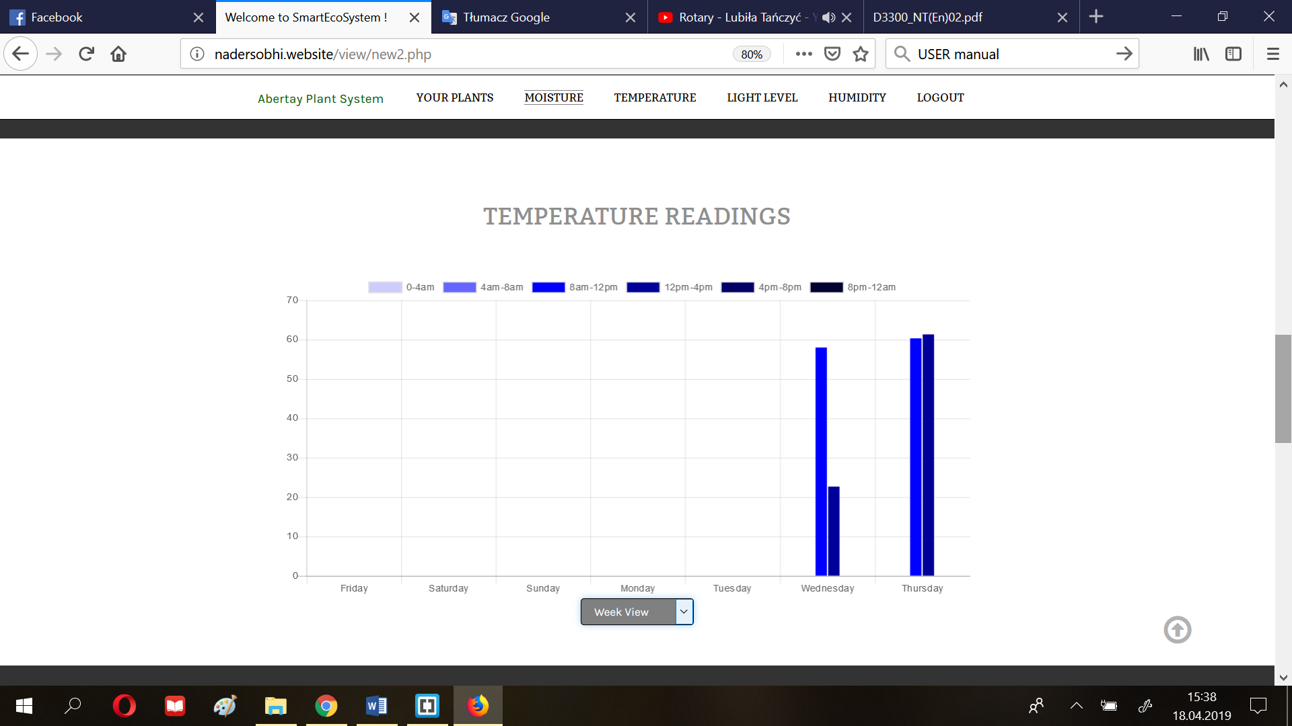

1. Decide on the time range of the analysed readings using the options (orange arrow)



References

**For URLs, Blogs:**

Bremer, J. 2012. *x86 API Hooking Demystified*. [blog]. 2 July. Available from: [http://jbremer.org/x86http://jbremer.org/x86-api-hooking-demystified/api-hooking-demystified/](http://jbremer.org/x86-api-hooking-demystified/) [Accessed 15 April 2016].

**Ours:**

**https://www.smallbusinesscomputing.com/News/Networking/what-the-internet-of-things-means-for-small-business.html**

<https://www.w3.org/standards/webdesign/accessibility>

<https://www.projectsmart.co.uk/project-planning-step-by-step.php>

# Appendices

## Appendix A - Example

Put any large amounts of data here (e.g. code).

**Hello.Php**

<html>

<head>

<title>PHP Test</title>

</head>

<body>

<p>Hello World</p>

</body>

</html>

## Appendix B - Example

And here….

## Appendix C - Suggestions for formatting figures/tables/screenshots in the body of the text

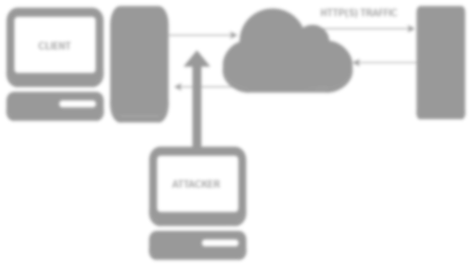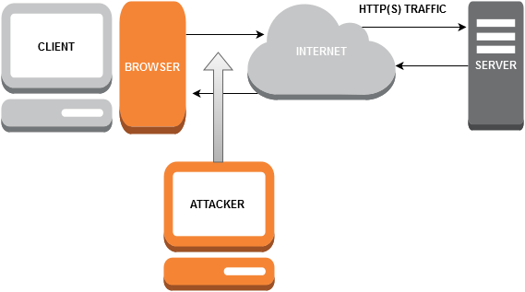

**Figure 1-1** A diagram of the system that was used in the security test.

**Table 1-1** Advantages of the X versus Y

|  |  |
| --- | --- |
| **Advantage Description** | |
| **1** | Can be programmed easier. |
| **2** | More flexible that the traditional system. |
| **3** | More secure than the traditional setup. |

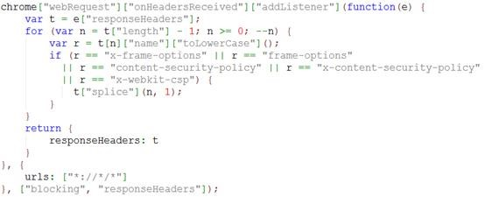

**Figure 1-1** Snippets of code can be formatted like this.

## Appendix D - Deliverables & requirements

**Agreement Form: Project Deliverables**

|  |  |
| --- | --- |
| **Group Number, Names of Team Members, and Programme** |  |
| **Programme specialist’s Name** |  |
| **The deliverables listed below will be submitted by the team by the due date.** | |
| **Part A deliverables** | **To be agreed by programme specialist and team, for example:**   * Executable code/investigation report * User/reference manual |
|  | * Requirements Specification, signed off by the programme specialist (see overleaf) * Software Design specification or investigation methodology * Testing * …. |
| **Programme specialist’s signature** |  |
| **Team members’ signatures** |  |

**Agreement Form: Requirements**

Group Number:

Team members (print):

Project Title:

Please refer to the attached documentation for full details on the project. The requirements are listed in Table 1. The signatures below indicate that the requirements for this project have been agreed by the project stakeholders.

Any changes to the project documentation should be made using the correct change authorisation procedure agreed with the programme specialist.

Table 1

|  |  |
| --- | --- |
| **ID** | **List of Agreed Requirements (fill in)** |
|  |  |

|  |  |  |
| --- | --- | --- |
| **Stakeholders** | **Signatures** | **Date** |
| Team members |  |  |
| Programme Specialist |  |  |
| Client (if applicable) |  |  |

## Appendix E - Minutes

This section should contain **detailed** minutes of meetings.

This should comprise:

• Date, time and venue of the meeting

• Who is present

• Any absences and apologies for absences received

• Approval or amendments of previous minutes if available (review)

• A description of what is discussed and agreed upon (or not) in the current meeting

• Any challenges flagged up (in the team) and how were they addressed

• Actions for next meeting

• Date, time and venue for next meeting

There should also be a brief section on the atmosphere/challenges within the team, how team dynamics were addressed etc.

## Appendix F – Other

1. Document prepared and revised by Natalie Coull, Colin McLean, Andrea Szymkowiak
2. Graham, G., 2005. *The White Paper FAQ (Frequently Asked Questions)/That White Paper Guy – Gordon Graham*. [online] Available at < <https://www.thatwhitepaperguy.com/white-paper-faq-frequently-asked-questions/#what_is>> [Accessed 9 May 2016].